

**Parking Challenges at Imtiaz Super Market: Developing a Smart Car Park System**

Prepared by:

**ALI-UR-REHMAN**

67XXX

**MUHAMMAD KUMAIL HASHIM**

67287

**AMIR ABBAS**

67XXX

**TABLE OF CONTENTS**

Contents

**1.** **Introduction** 3

**2.** **Literature Review** 5

**2.1.** **Model 1** 5

**2.2.** **Model 2** 6

**3.** **Designed Model** 9

**3.1.** **Overview** 9

**4.** **Methodology** 10

**4.1.** **Design steps** 10

**4.2.** **Detailed Connection Instructions** 11

**4.3.** **Implementation** 12

**4.4.** **Simulation** 13

**5.** **Methodology** 14

**5.1.** **Analysis** 14

**5.2.** **Improvements** 15

**6.** **References** 17

# **Introduction**

* 1. **Problem Statement**

Imtiaz Super Market, a popular retail destination in the Gulshan-e-Iqbal area of Karachi, Pakistan, faces a growing challenge in managing its parking facilities. As the supermarket's popularity continues to rise, the existing parking spaces have become increasingly overwhelmed, leading to several issues that impact both customers and the supermarket's operations.

The primary concerns include:

• **Congestion and Traffic Jams:** The limited parking spaces available often result in vehicles circling the lot, searching for an open spot. This causes traffic congestion both within the parking area and on the surrounding roads, frustrating customers and creating safety concerns [See ref: 1].

• **Inefficient Utilization of Spaces:** The current manual system of parking management fails to optimize the available spaces, leading to suboptimal utilization and missed opportunities to accommodate more vehicles [See ref: 2].

• **Lack of Visibility and Information:** Customers often struggle to determine the availability of parking spots, leading to unnecessary time spent searching and increasing the overall frustration with the parking experience [See ref: 3].

• **Delayed Entry and Exit:** The manual process of managing vehicle entry and exit further exacerbates the parking challenges, causing delays and long queues at the supermarket entrance and exit.

* 1. **Objective**

The goal of this research project is to develop a smart car park system for Imtiaz Super Market that leverages sensor technologies and circuit analysis to address the parking challenges faced by the supermarket. The proposed system aims to:

• Efficiently monitor and manage the availability of parking spots in real-time.

• Streamline the entry and exit process for vehicles, reducing congestion and delays.

• Provide clear and up-to-date information to customers about the parking status, enabling them to make informed decisions.

• Optimize the utilization of the available parking spaces, ensuring a more seamless and convenient experience for supermarket visitors.

• Explore the potential for future enhancements, such as integration with mobile applications and dynamic pricing models, to further improve the parking management system.

By developing this smart car park system, the goal is to enhance the overall customer experience at Imtiaz Super Market, while also addressing the operational challenges faced by the supermarket's management in managing the parking facilities.

# **Literature Review**

## **Model 1**

Pakistan's current parking system is heavily reliant on manual management, leading to several issues for both drivers and authorities:

• **Inefficiency:** The lack of clear signage and designated spaces forces drivers to search for vacant spots, wasting time and contributing to traffic congestion.

• **Lack of Transparency:** Fees are often unregulated and collected in cash, raising concerns about fairness for drivers and potential revenue loss for authorities. Discrepancies in collection can be a problem.

• **Security Concerns:** Unattended vehicles are vulnerable to theft or damage. Additionally, the safety of parking attendants collecting cash can be compromised.

These limitations highlight the need for a more modern and efficient parking management system in Pakistan.

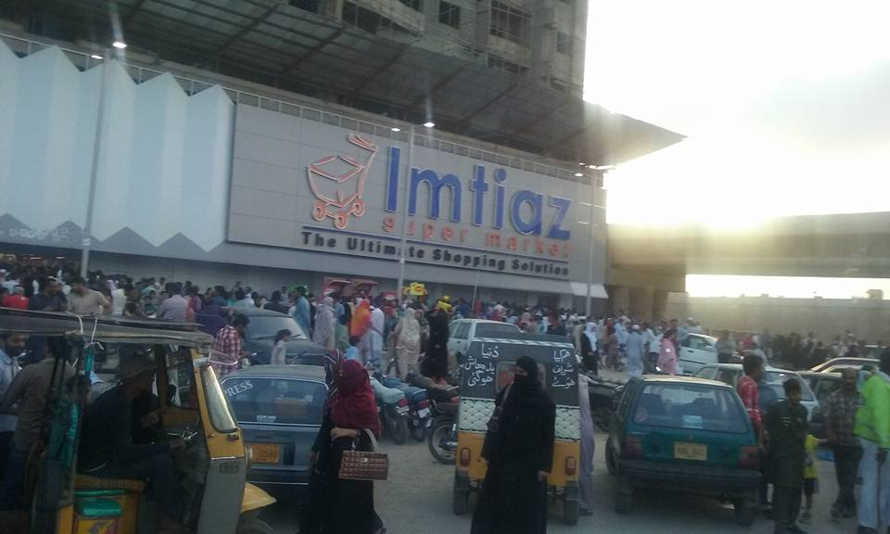

Current parking situation of Imtiaz supermarket

## **Model 2**

**Smart Parking: Optimizing Urban Efficiency**

Smart parking utilizes technology to streamline the parking experience, benefiting drivers, businesses, and city authorities. This report explores the concept, its functionalities, and the impact it has on urban environments.

**The Problem: Limited Parking and Frustrated Drivers**

Urban areas face a growing challenge: a lack of available parking spaces. This leads to wasted time circling for spots, traffic congestion, and driver frustration. Traditional parking management systems, with fixed signage and manual payment stations, are inefficient and inflexible.

**The Solution: Smart Parking Technology**

Smart parking systems leverage sensors, cameras, and software to create a dynamic and data-driven approach to parking management. Here's a breakdown of key functionalities:

• **Real-time Availability:** Sensors detect occupied and vacant spaces, providing drivers with instant information through mobile apps or digital displays. This reduces wasted time searching for parking [See ref: 4].

• **Automated Payment Systems:** Drivers can pay for parking seamlessly through their phones or contactless methods, eliminating the need for physical tickets and queue [See ref: 5].

• **Reservation Systems:** Advanced systems allow drivers to reserve parking spots in advance, guaranteeing a space upon arrival, especially useful for high-demand areas.

• **Navigation Guidance:** Mobile apps can integrate with smart parking systems, guiding drivers directly to available spaces, reducing traffic congestion caused by aimless searching [See ref: 4].

**Benefits of Smart Parking Systems**

The implementation of smart parking offers a multitude of advantages:

• **Reduced Traffic Congestion:** By minimizing search times, smart parking improves traffic flow and reduces emissions.

• **Enhanced Driver Experience:** Real-time information and convenient payment options create a smoother and less stressful parking experience.

• **Increased Revenue for Businesses:** Efficient parking management attracts customers to businesses with readily available parking.

• **Data-Driven Decision Making:** Collected data on parking usage helps authorities optimize parking allocation, pricing strategies, and infrastructure development.

Smart parking is a transformative technology for urban environments. By optimizing parking space utilization, it enhances driver experience, reduces traffic congestion, and provides valuable data for informed decision-making. As cities strive for efficiency and sustainability, smart parking will undoubtedly play a crucial role in shaping the future of urban mobility.

**Construction of Smart Parking Systems:**

A smart parking system typically consists of several key parts:

• **Sensors:** These can be ultrasonic, magnetic, or cameras to detect the presence or absence of a vehicle in a parking space.

• **Microcontroller Unit (MCU):** This is the brain of the system, processing data from the sensors and controlling other components.

• **Communication Module:** This might be a cellular network connection or Bluetooth to transmit data to a central server or mobile app.

• **Power Supply:** This could be mains power or a battery depending on the configuration.

Here's a simplified illustration of how these components might be connected:

[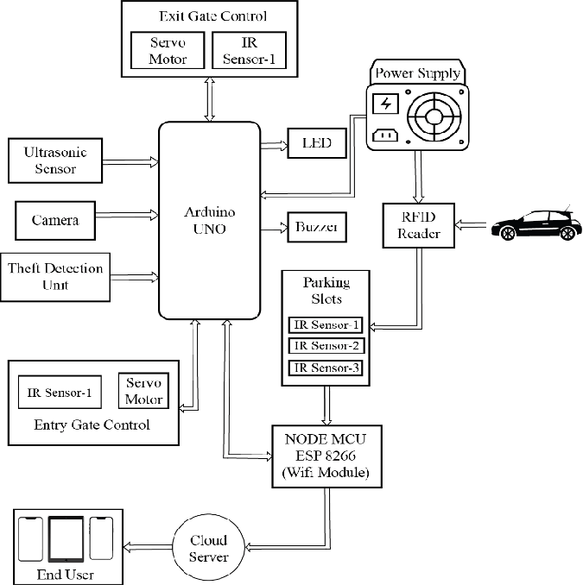](https://www.researchgate.net/figure/Block-Diagram-of-Smart-Parking-System_fig1_353356478)

The specific circuits for each component would depend on the chosen technology and functionalities.

# **Designed Model**

## **Overview**

## The parking management system will use an Arduino Uno as the main controller, along with a PIR sensor to detect vehicles, an LCD display to show the parking status, an L293D motor driver to control the gate motor, and a DC motor to physically open and close the gate.

## When a vehicle approaches the parking spot, the PIR sensor will detect motion and send a signal to the Arduino. The Arduino will then display "Vehicle Detected" on the LCD screen and activate the motor driver to open the gate. After a 5-second delay (to allow the vehicle to enter), the Arduino will activate the motor driver to close the gate.

## If no motion is detected, the Arduino will display "No Vehicle" on the LCD screen. The system will continuously monitor for vehicles by repeating the loop every 100 milliseconds.

## **Components and Connections**

## 1. **Arduino Uno:** The main controller that will process the sensor input, control the display, and drive the motor.

## 2. **PIR Sensor:** Connected to digital pins on the Arduino to detect motion and vehicles.

## 3. **LCD Display:** Connected to the Arduino using the I2C protocol (SDA to A4, SCL to A5) to display the parking status.

## 4. **L293D Motor Driver:** Connected to the Arduino to control the DC motor:

## **Motor A:**

## IN1 -> D4

## IN2 -> D5

## **Motor B:**

## IN3 -> D6

## IN4 -> D7

## **Enable Pins:**

## ENA -> D8

## ENB -> D9

## 5. **DC Motor:** Connected to the L293D motor driver to physically open and close the gate.

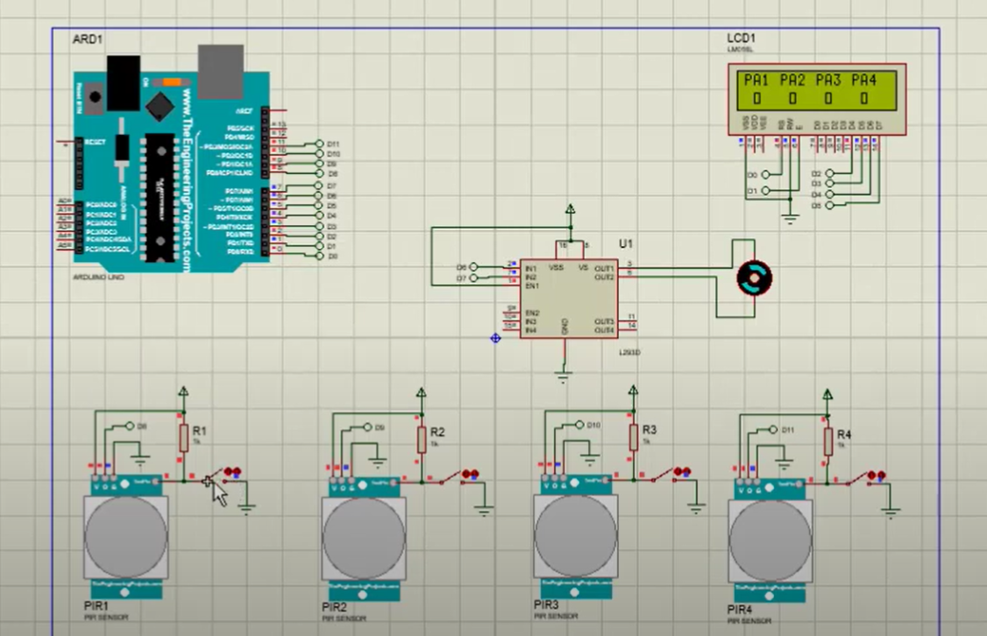Circuit Diagram of parking system

# **Methodology**

## **Design steps**

**Pseudocode**

Initialize LCD display

Initialize PIR sensor pins as input

Initialize motor driver pins as output

while true:

if PIR sensor detects motion:

Display "Vehicle Detected" on LCD

Activate motor to open gate

Delay for 5 seconds

Activate motor to close gate

else:

Display "No Vehicle" on LCD

end if

Delay for 100 milliseconds

end while

## **Detailed Connection Instructions**

1. **PIR Sensor**

• **VCC:** Connect to 5V on the Arduino.

• **GND:** Connect to GND on the Arduino.

• **OUT:** Connect to a digital pin (e.g., D2) on the Arduino.

1. **LCD Display (I2C)**

• **SDA:** Connect to A4 on the Arduino.

• **SCL:** Connect to A5 on the Arduino.

• **VCC:** Connect to 5V on the Arduino.

• **GND:** Connect to GND on the Arduino.

1. **L293D Motor Driver**

• **Motor A (Gate Motor)**

**IN1:** Connect to D4 on the Arduino.

**IN2:** Connect to D5 on the Arduino.

• **Motor B**

**IN3:** Connect to D6 on the Arduino.

**IN4:** Connect to D7 on the Arduino.

• **Enable Pins**

**ENA:** Connect to D8 on the Arduino.

**ENB:** Connect to D9 on the Arduino.

• **Power**

**VCC:** Connect to 5V on the Arduino.

**GND:** Connect to GND on the Arduino.

## **Implementation**

To implement the parking management system, you can use the Arduino IDE to write and upload the code to the Arduino Uno. Here's a step-by-step guide:

1. **Install the Arduino IDE on your computer if you haven't already.**

2. **Connect the Arduino Uno to your computer using a USB cable.**

3. **Open the Arduino IDE and create a new sketch.**

4. **Include the necessary libraries:**

* + - * LiquidCrystal_I2C.h for the LCD display
      * AFMotor.h for the motor driver

5. **Initialize the LCD display, PIR sensor pins, and motor driver pins in the setup() function.**

6. **Write the main loop to continuously monitor for vehicles using the PIR sensor:**

* + - * If motion is detected, display "Vehicle Detected" on the LCD and activate the motor to open the gate.
      * After a 5-second delay, activate the motor to close the gate.
      * If no motion is detected, display "No Vehicle" on the LCD.
      * Delay for 100 milliseconds before repeating the loop.

7. **Upload the code to the Arduino Uno using the Arduino IDE.**

8. **Connect the components according to the circuit diagram:**

* + PIR sensor to digital pins
  + LCD display to A4 (SDA) and A5 (SCL) using I2C
  + L293D motor driver to digital pins for motor control
  + DC motor to the motor driver

9. **Test the system by waving your hand in front of the PIR sensor to simulate a vehicle approaching. Observe the LCD display and the gate opening and closing.**

## **Simulation**

1. **Open Proteus and create a new project.**

2. **Add the following components to the simulation:**

* + Arduino Uno
  + PIR sensors (one for each parking spot)
  + LCD display
  + L293D motor driver
  + DC motor

3. **Connect the components as per the circuit diagram:**

* + - * Connect the PIR sensors to digital input pins on the Arduino.
      * Connect the LCD display to the Arduino using the I2C protocol (SDA to A4, SCL to A5).
      * Connect the L293D motor driver to the Arduino for controlling the DC motor:
    - Motor A: D4 (IN1), D5 (IN2)
    - Motor B: D6 (IN3), D7 (IN4)
    - Enable pins: D8 (ENA), D9 (ENB)
* Connect the DC motor to the L293D motor driver.

4. **Write the Arduino code in the Proteus simulation software's code editor. The code should include the following functionality:**

* + - * Initialize the LCD display and PIR sensor pins.
      * In the main loop, continuously monitor the PIR sensors to detect vehicle presence.
      * When a vehicle is detected, display "Vehicle Detected" on the LCD and activate the motor driver to open the gate.
      * After a 5-second delay, activate the motor driver to close the gate.
      * If no vehicle is detected, display "No Vehicle" on the LCD.
      * Repeat the loop with a 100-millisecond delay.

5. **Compile and upload the Arduino code to the simulated Arduino Uno in Proteus.**

6. **Simulate the system by triggering the PIR sensors (e.g., by clicking on them in the Proteus simulation). Observe the LCD display and the motor driver controlling the DC motor.**

7. **Debug and modify the code as needed until the simulation works as expected.**

By using Proteus, you can simulate the parking management system and test the functionality of the Arduino code and circuit connections before implementing the physical system. This allows you to identify and fix any issues early in the development process, saving time and resources.

# **Methodology**

The simulation demonstrates the continuous monitoring of parking spots by the PIR sensors. The LCD display is updated accordingly, showing "No Vehicle" when no vehicle is detected and the parking status when a vehicle is present.

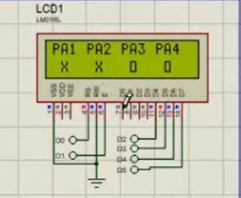

Screenshot of the output

## **Analysis**

**The Parking Problem**

The parking management system designed using the Arduino Uno, PIR sensors, LCD display, motor driver, and DC motor provides several benefits to address the parking challenges faced by Pakistani supermarkets:

1. **Efficient Parking Spot Utilization:** The system continuously monitors parking spots using PIR sensors and updates the real-time availability and occupancy status. This allows customers to quickly find the nearest available spot, reducing the time spent searching for parking.
2. **Automated Gate Control:** Based on detected vehicle presence, the system automatically opens and closes the parking gate. This streamlined process enhances entry and exit efficiency, preventing traffic congestion at the parking lot entrance.
3. **Parking Status Visibility:** The LCD display provides clear and current information about available and occupied parking spots. Customers can make informed decisions about entering the parking lot, minimizing frustration over finding a spot.
4. **Scalability:** The system's modular design facilitates easy expansion for larger parking areas. Additional PIR sensors can monitor more spots, and the LCD display can be upgraded to offer more detailed information as needed.
5. **Cost-Effectiveness:** Utilizing cost-effective components like the Arduino Uno, PIR sensors, and readily available motor driver makes the system financially viable for implementation in Pakistani supermarkets, where budget constraints may apply.
6. **Adaptability:** The system can adapt to specific supermarket requirements, such as adjusting gate operation timings or displaying additional information like parking fees or reserved spots, enhancing its utility across different locations.
7. **Reduced Emissions:** By optimizing the parking process and minimizing vehicle search times, the system contributes to reduced fuel consumption and lower emissions. This aligns with environmental sustainability objectives by promoting efficient resource use.

## **Improvements**

As the popularity of supermarkets continues to grow in Pakistan, the need for efficient and well-managed parking facilities has become increasingly important. Customers expect a seamless parking experience, with easy access to available spots and a hassle-free entry and exit process. To address these challenges, we have developed a comprehensive parking management system that utilizes cutting-edge technology to optimize the parking experience.

At the heart of our system is the Arduino Uno, a versatile microcontroller that serves as the brain of the operation. Strategically placed infrared (PIR) sensors monitor each parking spot, detecting the presence of vehicles and relaying this information to the Arduino. This real-time data is then displayed on a user-friendly LCD screen, allowing customers to quickly identify the nearest available spot.

The system's automated gate control is a game-changer. When a vehicle approaches the entrance, the Arduino activates the L293D motor driver to open the gate, streamlining the entry process and preventing traffic congestion. After a short delay, the gate is then closed, ensuring the efficient utilization of the parking spaces.

One of the standout features of our system is its scalability. As the supermarket's parking needs grow, additional PIR sensors can be seamlessly integrated, allowing the system to monitor a larger number of parking spots. The modular design also makes it easy to upgrade the LCD display, providing customers with more detailed information, such as parking fees and reserved spot availability.

Affordability is another key consideration, especially in the Pakistani market where budgets can be constrained. By leveraging cost-effective components like the Arduino Uno and off-the-shelf motor drivers, we have developed a solution that is not only effective but also financially accessible for supermarket owners.

Looking to the future, we envision further enhancements to our parking management system. Integrating advanced sensor technologies, such as ultrasonic sensors and camera-based systems, can provide even more accurate vehicle detection and identification capabilities. Incorporating machine learning algorithms to predict parking patterns can optimize spot allocation and enhance the customer experience.

Moreover, the integration of a mobile app can revolutionize the parking experience. Customers can view real-time availability, reserve and pay for spots in advance, and receive notifications about their parking session. Dynamic pricing models can also be implemented to manage demand during peak hours or special events.

By addressing the unique challenges faced by Pakistani supermarkets, our parking management system offers a comprehensive solution that not only improves efficiency but also enhances the overall customer experience. As we continue to refine and expand our offerings, we are confident that our system will become an indispensable asset for supermarket owners, contributing to the growth and success of the retail industry in Pakistan.

# **References**

**Reference1:** https://www.sciencedirect.com/science/article/pii/S2095756423001253

**Reference2:**

https://ieeexplore.ieee.org/document/6492250

**Reference3:** https://www.sciencedirect.com/science/article/abs/pii/S2212012214000562

**Reference4:**

SMART PARKING SYSTEM RAAHUL SURESH SESI 2022/2023 - Politeknik Sultan Salahuddin Abdul Aziz Shah)

**Reference5:**

https://www.ijsrp.org/research-paper-0515/ijsrp-p41108.pdf

pen_spark